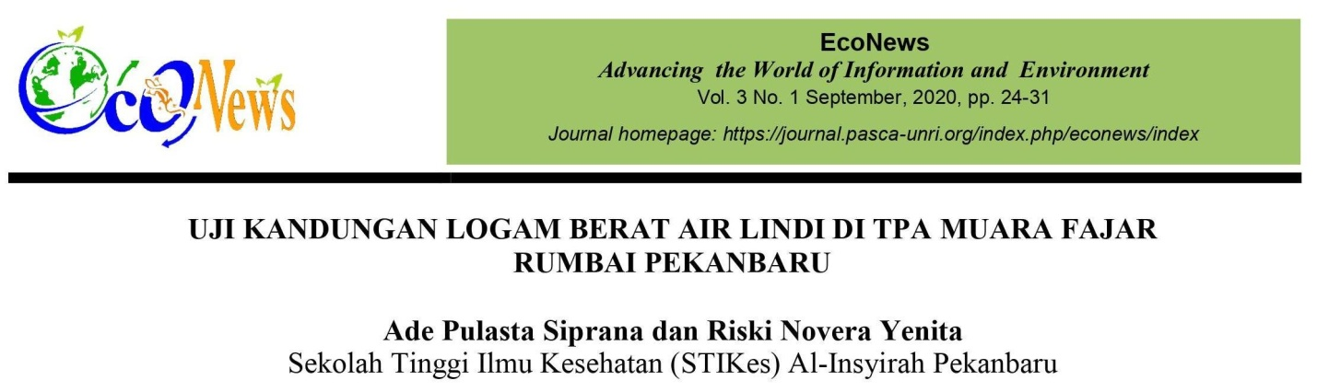

ABSTRACT

The existence of a finishing plant (TPA) often creates a dilemma that causes air pollution. Decomposition of waste causes air pollution, contamination of water and soil due to leakage of leachate, and harms health. Landfills where rainwater accumulates due to large amounts of landfilling and leachate (water with deposited waste) is generated, causing deterioration of water quality, which leads to deterioration of water quality in the surrounding area. The purpose of this study is to know the heavy metal content of the leachate of TPA Muara Fajar Rumbai Pekanbaru. This survey was conducted from June 2016 to December 2016. Sampling location at TPA Muara Fajar Pekanbaru. Where to perform leachate analysis at his UPT testing laboratory office in Riau Public Works. The methodology used in this study is a study using the Muara Fajar Pekanbaru TPA as the sampling site. The collected samples were then analyzed in the laboratory for heavy metal content (Pb, Cd, Cu) and the resulting data were analyzed descriptively according to SNI 06-2412-1991. The heavy metal cadmium (Cd) content in the leachate was 0.8 mg/ppm for tanks 1 and 2 and 0.7 mg/ppm for tank 3, exceeding the specified quality standards. Levels of heavy metal copper (Cu) in the leachate exceeded specified quality standards at 3.1 mg/ppm in tank 1, 3 mg/ppm in tank 2, and fell below quality standards at 2.9 mg/ppm in tank 3 . reached. The lead weight metal (Pb) content for tanks 1 and 2 was 2.26 mg/ppm, while tank 3 was 2.24 mg/ppm, exceeding the specified quality standards.
Keywords: gynecological examination, heavy metals, exudates
