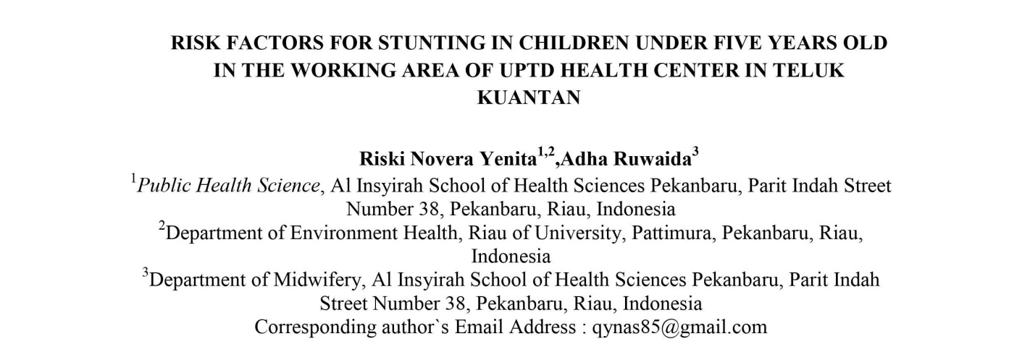
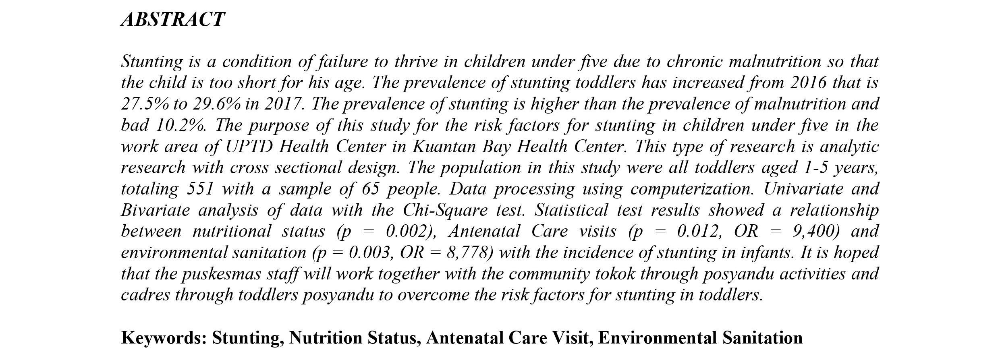

Introduction

Reputation for infant and young child nutrition is a hallmark of human health and well-being. U.s. of. Getting the best healthy nutrients at a young age isan importantfoundation for lifelong health. Malnutrition in infants can interfere with their growth improvement. At this age, the need for electricity, protein, nutrients and minerals is so great that important hobbies related to food intake from father and mother are necessary. age at high risk for above problems (UNICEF, 2012). A short baby (stunted) can be seen when a child has their height or height measured and the results are below average on normal assessments. Smaller infants are those with higher nutritional ratings based primarily on age.
