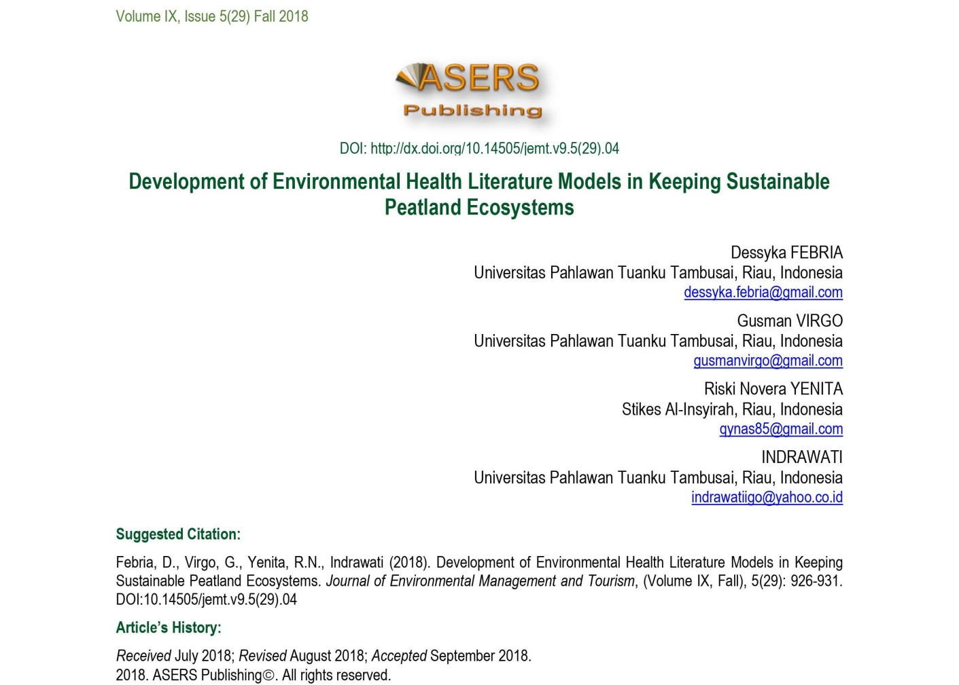Abstract
this text discusses the development of a version of environmental fitness literacy to keep a sustainable environment on peatlands. In preserving the sustainable peatland surroundings, an environmental health literacy version is needed so that the network can observe up on the fitness of the encircling environment. To make knowledgeable selections, communities have to have the capacity to achieve, technique and recognize health and environmental records.
The procedures used in environmental health literacy are 1 - basic, and practical literacy with efforts to assess environmental health statistics, 2 - communicative interactive and recognition literacy in decreasing health and environmental risks and 3 - improving best of existence and defensive the surroundings with offer education as a way to change people's conduct. in the end, efforts to expand this model of environmental health literacy are meant to prevent the occurrence of peatland atmosphere damage and can empower groups via an improved know-how of health risks and environmental dangers that have an effect on health and the environment.
key phrases: environmental fitness literacy models; sustainability peatlands environment.JEL Classification: K32; O13; Q10

Introduction
The fundamental environmental problem we face today is that of ecosystems. An environmental problem facing us today is the destruction of peatlands. The problem is caused by human-induced environmental changes that make the environment unable to support human life. If we do not solve the problem of peatland management soon, it will affect human well-being. Peatlands are soils formed from accumulations of semi-decayed vegetation so as to have a high organic matter content. According to Bellamy (1995), peatlands have several strategic functions that are essential for environmental comfort and animal life, including hydrological functions such as carbon sequestration and biodiversity. Damage to peat ecosystems has severe impacts on the local environment,

