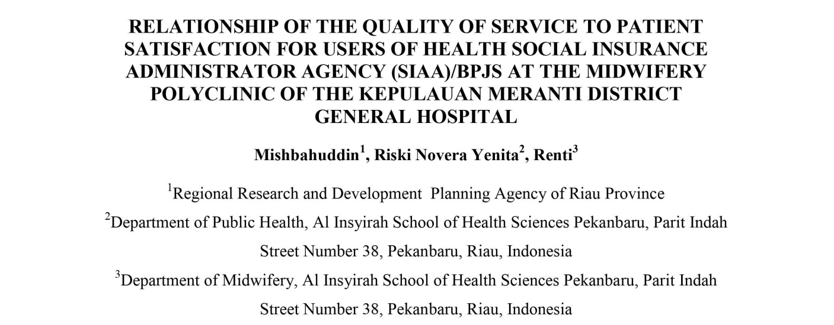
ABSTRACT

The service exception is a form of data subject assessment of the scope of the service provider. Appropriate service is the service to fulfill the wishes or expectations of those affected, which can lead to patient satisfaction. This research aims to determine the association between first class carrier and patient satisfaction for clients of the Employer of Social Security Administrators (SIAA) / BPJS at the Kepulauan Meranti District Medical Facility Midwifery Polyclinic taking place from December 2020 to January 2021. The study type is a quantitative study using a move section technique. The sample size is 98 respondents for the targeted sampling method. The results of univariate and bivariate statistical analysis using the Kolmogorov-Smirnov Z look at the acquired P fee of null.111 (P > null.1/2). It suggests that there may not be a correlation between best-of-service and patient satisfaction. It was hoped that the implications of this investigation could be an indication for improving the quality of the Health Authority (SIAA) / BPJS in the trendy Kepulauan Meranti District health hub. Keywords: quality of service, patient satisfaction

