

ABSTRAK

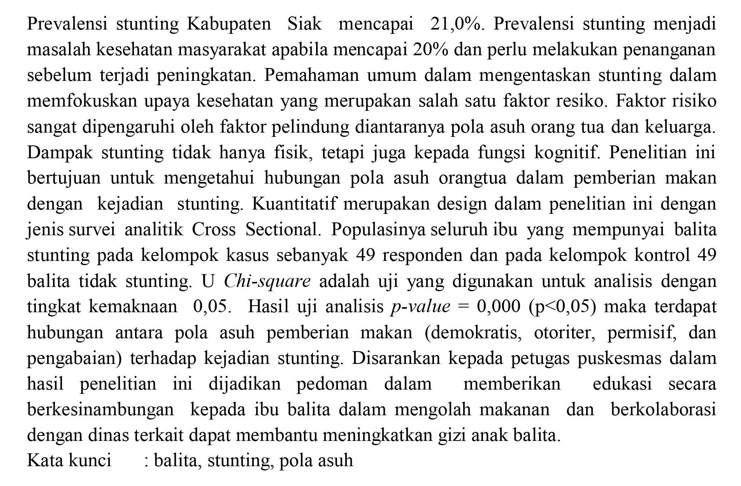
ABSTRACT
The Prevalence of stunting in Siak Regency reached 21.0%. incidence of stunting will become a public health problem if it reaches 20% and needs to be dealt with earlier than it increases. the overall know-how in alleviating stunting is to consciousness on health efforts which can be threat elements. while danger elements are strongly influenced by using protecting elements along with parenting / own family. Stunting could have an effect no longer best physically, but additionally on cognitive function. This study goals to determine whether there's a courting between feeding parenting and the prevalence of stunting. The research layout used is quantitative with a cross sectional analytic survey. The research subjects

