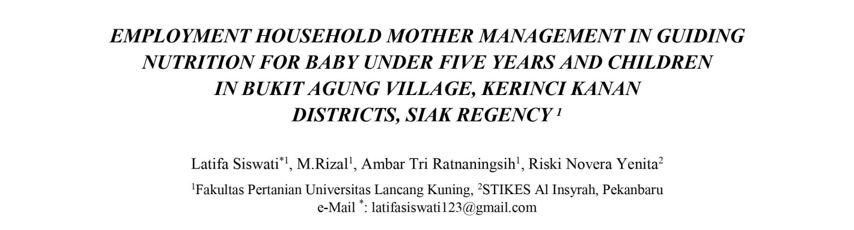
Abstract
Homes play an important role in regulating the health of their relatives by regulating vitamin consumption in infants and children. So it may have been a healthy and nutritious meal. Through the use of nearby nutritional supplements, we hope to empower housewives in the use of vitamins and children.The motivation for willpower is to: 1) Empower housewives by regulating infant and infant vitamins 2) increasing the expertise and ability of housewives to transform backyard meals into healthy, nutritious meals; The entertainment took place in Bukit Agung Village, Kerinci Kanan District, Siak District, Riau Province. The approach used is consulting and training. Our approach to member selection is through targeted sampling. That is, farmers who are likely to be able to use their backyards for medicinal plants, food crops, gardening, fish, etc. to satisfy the needs of their relatives. The impact of this entertainment was that after counseling, housewives' knowledge of a nutritious food supply for infants and toddlers increased to 20.83%, and nutritional benefits to baby growth and improvement could increase to 25%. suggests. Trained housewives can benefit from eating plenty of healthy, nutritious foods like puddings and meatballs in the backyard of their homes.

Keywords: empowerment, housewife, fitness, vitamins.

¹ Dipresentasikan pada Konferensi Nasional PkM-CSR, Lombok, 23-25 Oktober 2018

