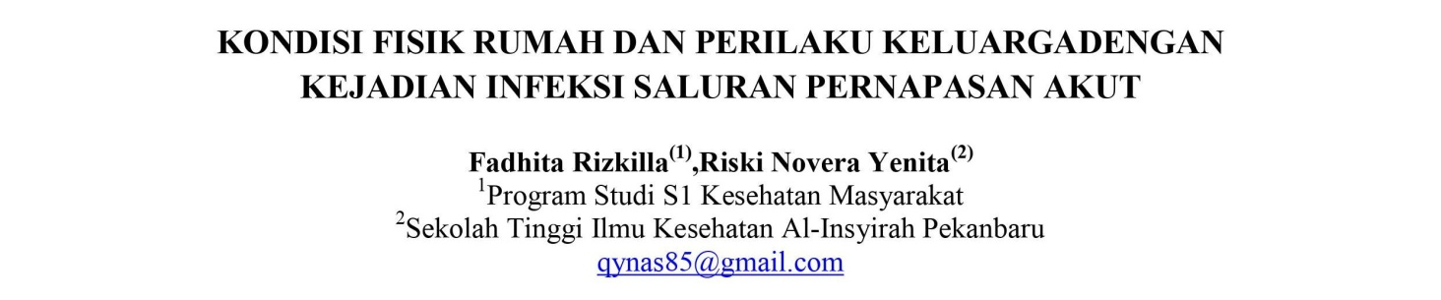
ABSTRAK
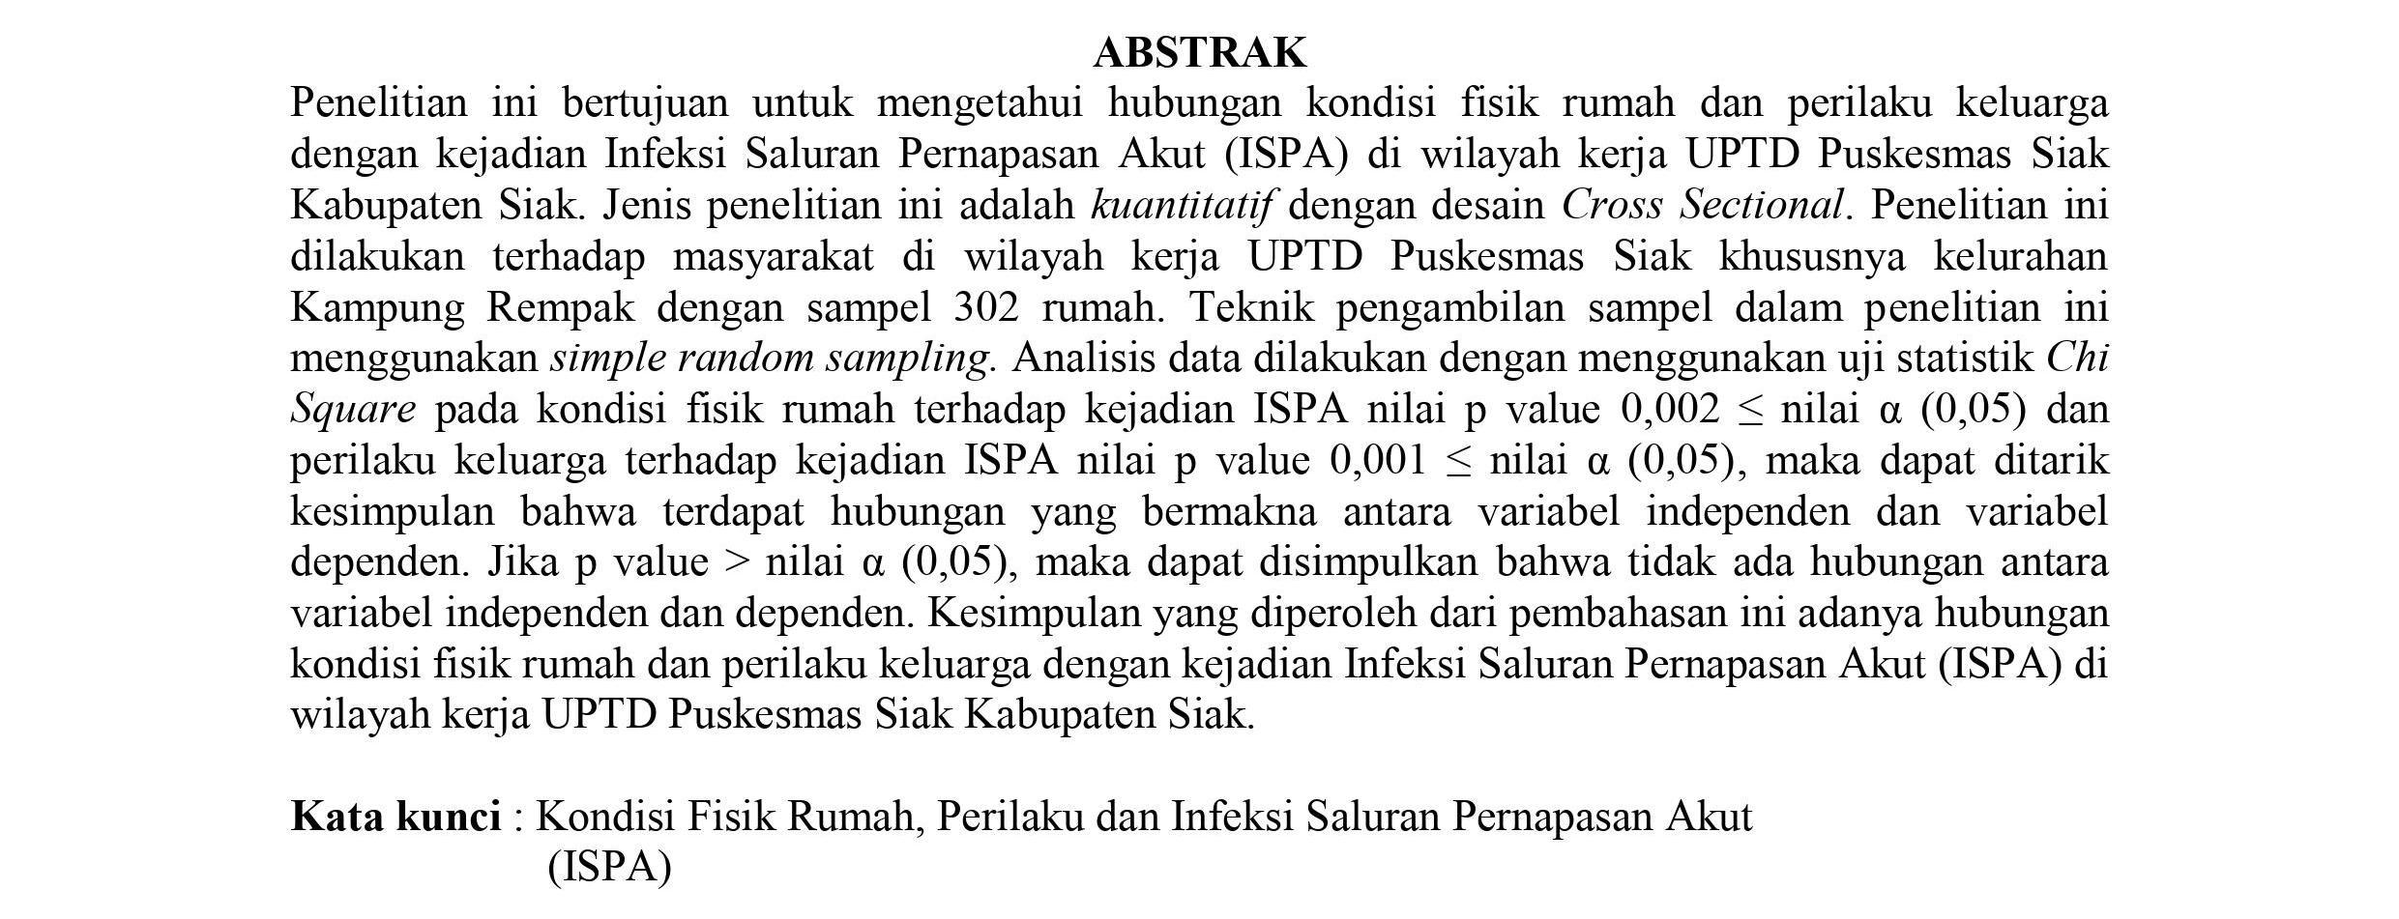
ABSTRACT
This take a look at aims to clarify the relationship among domestic health and own family behaviors and prevalence of acute breathing infections (ARI) inside the place of job of UPTD clinic Siak, Siak District. This type of look at is quantitative with a go-sectional design. The survey turned into conducted the use of a sample of 302 households within the offices of UPTD health center Siak, mainly inside the network of Kampung Rempak Village. The sampling method for this take a look at uses simple random sampling. data were analyzed the use of the chi-rectangular statistical check of domestic physical popularity at the occurrence of ARI p-values zero.002 ≤ α(0.05), and family behavior for ISPA p-values zero.001 ≤ α(0.05). Analyzed. From this we are able to finish that there is a considerable courting among the independent and dependent variables. If the p-value > α-cost (zero.05), you could finish that there may be a giant affiliation between the independent and dependent variables. If the p-value > alpha cost (zero.05), it's miles concluded that there is no courting between the independent and based variables. the realization of this dialogue is the relationship among the bodily nation of the home and behavior. UPTD medical institution Siak A family with an acute respiration contamination (ARI) in Siak District.
key phrases: physical circumstance/conduct at home/acute breathing infection (ARI)

