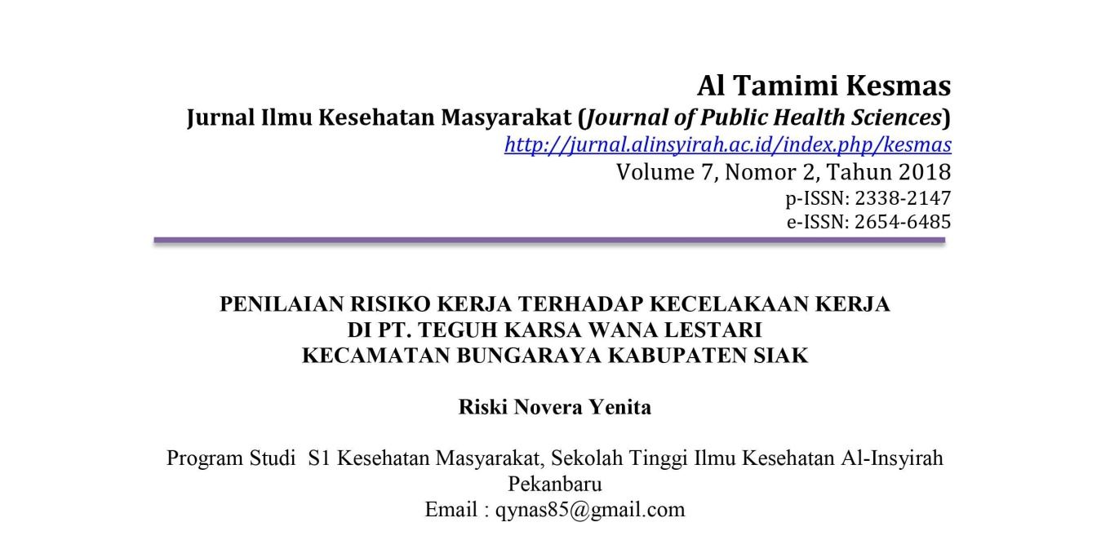
ABSTRAK

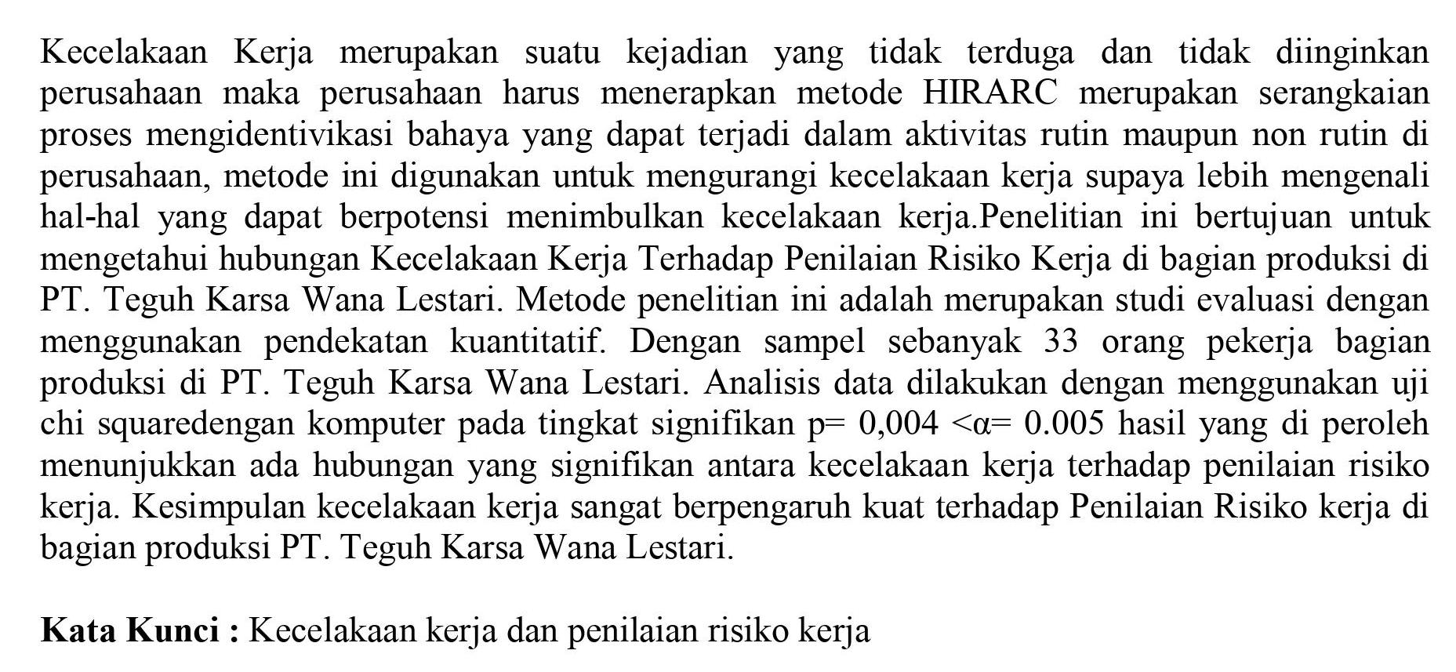

ABSTRACT

Twist of fate of pastime constitute an occurence which do not be anticipated and do not be wanted via corporation because of this corporation should comply with approach of HIRARC represent to with confer with method of mengidentivikasi chance capable of befell in habitual hobby and additionally non routine in agency, this method isused to lessen twist of fate of hobby just so more is spotting of efficiency things capable of generate twist of fate of this work. Study motive to to apprehend relation accident Of hobby To assessment of threat art work in a part of manufacturing in PT. Unshakeable of everlasting Karsa Wana. this method studies is to represent have a take a look at have a look at via the use of the use of quantitative technique. With sampel counted 33 employee humans a part of production in PT. Unshakeable of everlasting Karsa Wana. assessment facts finished with the beneficial aid of the usage of take a look at of chi rectangular with computer at storey;level of large p= zero,004 <α = 0.half of result of which in obtaining to show there may be relation this is vast among coincidence of hobby to evaluation of activity threat. cease of twist of fate of hobby very is having an effect on of energy to evaluation of hazard artwork in a part of manufacturing of PT. Unshakeable of everlasting Karsa Wana.
key phrases : twist of fate Of activity and evaluation of pastime threat

