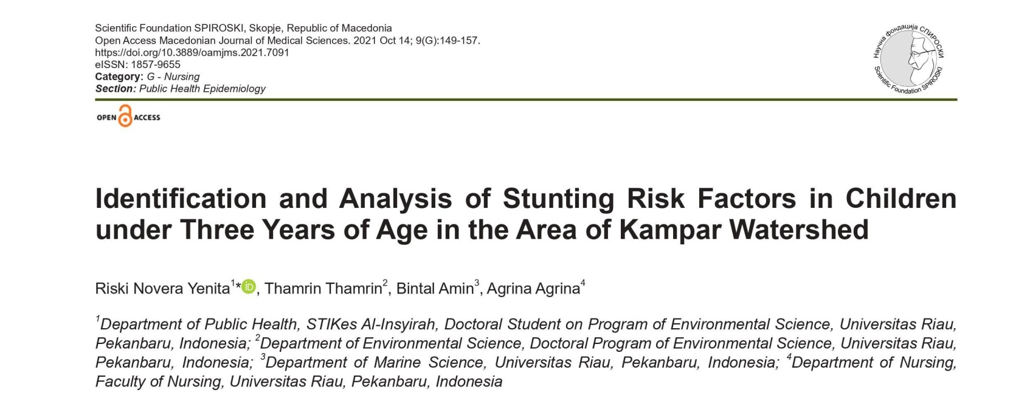

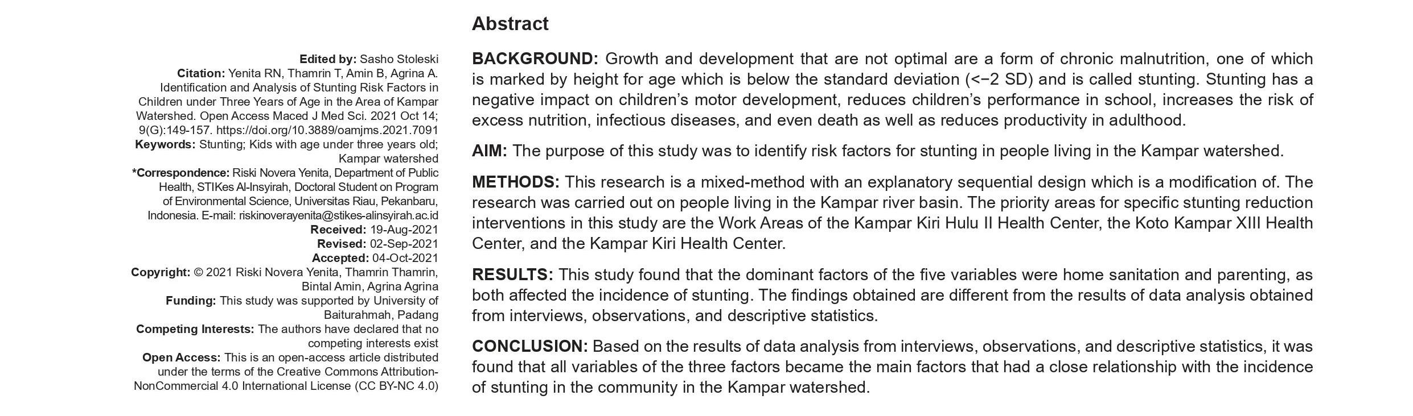
Suboptimal boom and development early in lifestyles is a health trouble found in nearly all regions of the arena, specifically in economic sectors. ) or a form of chronic malnutrition characterised via so-known as stunting [1], [2]. [3], [4]. growth retardation at 12–24 months of age, or quick stature, is because of insufficient meals intake and frequent infections. Stunting adversely affects a infant's motor development, impairs instructional overall performance, increases the threat of overeating, infections and even demise, and reduces productivity in maturity. Postpartum periods without linear growth variety from three–6 months to 24–36 months [5]. A WHO hearing located that hygiene turned into the principle component in lowering her risk of stunting in kids under 5 [6]. In numerous international locations, attention to environmental factors remains growing exponentially. In 2016, there have been 22.9% or 154.eight million underage youngsters, with 6 million of them in Latin the usa and the Caribbean. West Africa (31.four%), important Africa (32.five%), East Africa (36.7Persen), South Asia (34.1Persen), Oceania (38.3Persen), except for Australia and New Zealand [7]. In 2013, more than one-third (37%) of children beneath the age of five in 15 of Indonesia's 33 provinces were discovered to be afflicted by stunting with a incidence of over 40%. . in retrospect, information gathered in simple health studies (2010) show that the superiority of stunted toddlers continues to growth, specifically in the 12-23 month old group. increased from age organization (28.1%)
< 5 months (32.1%) in the 6-eleven month antique group and elevated to (41.5%) inside the 12-23 month vintage organization Riau et al. [8], Torlesse et al. [9] states that Indonesia has 3 districts with a prevalence of stunting of 28.4% and a occurrence of intense stunting of 6.7%. Goodarz [10] provides that there are 18 modifiable hazard elements for growth retardation.

