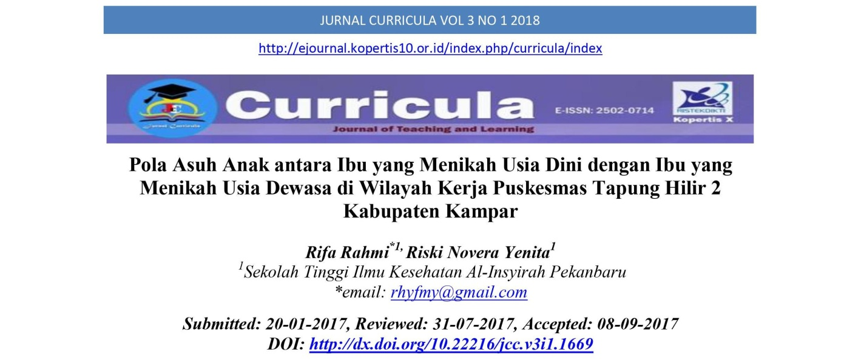Abstrak

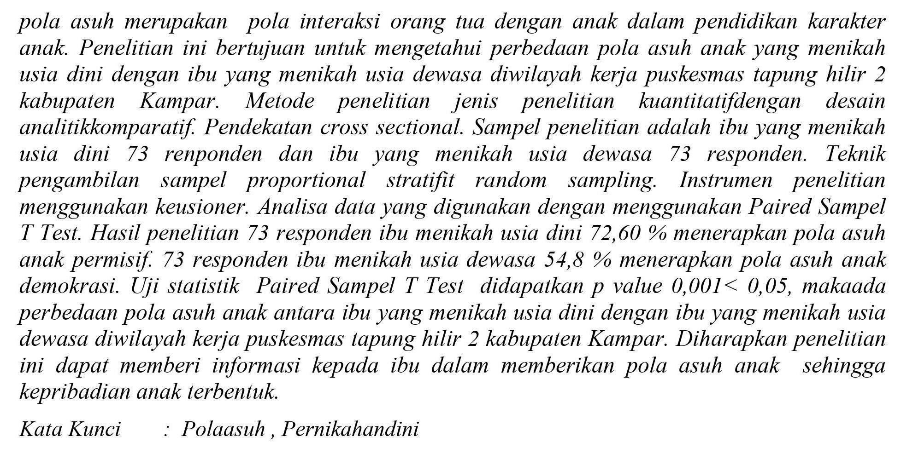Abstract
Differences in parenting amongst single moms and married mothers in early maturity. The motive of this observe was to have a look at the variations in parenting of early-married kids and person unmarried moms in the paintings area of the Tapung Hilir 2 Kabupaten Kampar health center. to perceive. take a look at methods A quantitative take a look at with a comparative analytical design. cross-slicing approach. The observe pattern consisted of moms who married early at age 73 and single mothers who reached maturity at age 73. Stratified proportional sampling of random samples. Survey device. evaluation of facts used in paired-samples t-tests. Of the 73 moms surveyed, early marriage ended in 72.60% being considered permissive upbringing. Of her seventy three mothers interviewed, 54.eight% had been married adults practicing democratic parenting. The paired-samples statistical t-check yielded a p-value of zero.001. Then there are differences in parenting among mothers who married early in adulthood and people who married early.

